**//java placement day 2**

//swapping of 2 var by add and sub

public class Main {

public static void main(String[] args) {

int a=20, b=10;

a=a+b;

b=a-b;

a=a-b;

System.out.println(a+" "+b);

}

}

//swapping using mul and div

public class Main {

public static void main(String[] args) {

int a=20, b=10;

a=a*b; //200

b=a/b; //10

a=a/b; //20

System.out.println(a+" "+b);

}

}

//swapping using ex or gate

public class Main {

public static void main(String[] args) {

int a=20, b=10;

a=a^b; //15

b=a^b; //10

a=a^b; //5

System.out.println(a+" "+b);

}

}

//Runtime input

Scanner class

creating object Classname object = new Classname();

import java.util.Scanner is a file containing a nested file as only scanner

import java.util* conatain all java file //

example program using swap using runtime

import java.util.*;

public class Main {

public static void main(String[] args) {

Scanner sc = new Scanner(System.in);

System.out.println("Enter A value: ");

int a= sc.nextInt();

System.out.println("Enetr B value: ");

int b=sc.nextInt();

System.out.println("A = "+a+" B = "+b);

}

}

**OUTPUT:**

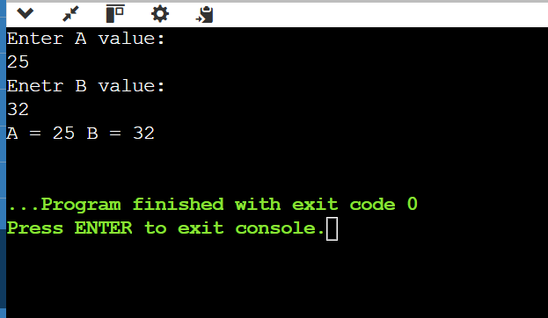

INPUT DATATYPES

nextInt()

nextByte()

nextShort()

nextFloat()

nextLong()

nextDouble()

nextBoolean()

for sting the input type is

String str = sc.next(); //This accepts only first word and its terminator line space

String str=sc.nextLine() -> terminator line is enter

//Index reference of user input

char str= scan.next().charAt(0);

java program

import java.util.*;

import java.util.Scanner;

public class Main {

public static void main(String[] args) {

Scanner sc = new Scanner(System.in);

char c = sc.next().charAt(3);

System.out.println(c);

}

}

//Program 2

import java.util.*;

import java.util.Scanner;

public class Main {

public static void main(String[] args) {

Scanner sc = new Scanner(System.in);

int a=sc.nextInt();

sc.nextLine();

String c = sc.nextLine();

System.out.println(a+" "+c);

}

}

**Conditional STATEMENTS**

**IF, IF ELSE, IF ELSE IF, SWITCH, NESTED IF**

**If statement**

import java.util.*;

import java.util.Scanner;

public class Main {

public static void main(String[] args) {

Scanner sc = new Scanner(System.in);

int a=sc.nextInt();

if(a%2==0) {

System.out.println("Even");

} if(a%2!=0) {

System.out.println("Odd");

}

}

}

Output;

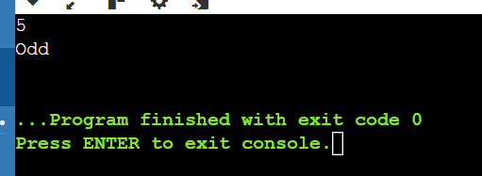

**If else**

import java.util.*;

import java.util.Scanner;

public class Main {

public static void main(String[] args) {

Scanner sc = new Scanner(System.in);

int a=sc.nextInt();

if(a%2==0) {

System.out.println("Even");

} else {

System.out.println("Odd");

}

}

}

**If else if statement**

import java.util.*;

import java.util.Scanner;

public class Main {

public static void main(String[] args) {

Scanner sc = new Scanner(System.in);

int a=sc.nextInt();

int b=sc.nextInt();

int c=sc.nextInt();

if(a>b && a>c) {

System.out.println(a);

} else if(b>c) {

System.out.println(b);

} else {

System.out.println(c);

}

}

}

**Nested if statement**

import java.util.*;

import java.util.Scanner;

public class Main {

public static void main(String[] args) {

Scanner sc = new Scanner(System.in);

int a=sc.nextInt();

if(a%2==0) {

if(a%3==0) {

System.out.println("Divisible by 2 and 3");

} else{

System.out.println("Divisible only by 2");

}

}

}

}

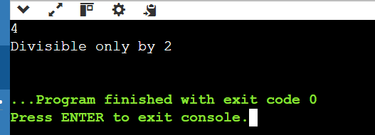

Switch Statements

Condition:

* case value should contain only integers and not float or decimals.
* case value does not be duplicate.

Java program to calculate garde:

import java.util.*;

class Main {

public static void main(String[] args) {

Scanner sc = new Scanner(System.in);

System.out.println("Enter your marks: ");

int a = sc.nextInt();

if ((a>90) && (a<=100))

System.out.println("O Grade");

else if ((a>80) && (a<=90))

System.out.println("A grade");

else if ((a>70) && (a<=80)):

System.out.println("B Grade");

else if ((a>60) && (a<=70))

System.out.println("C Grade");

else if ((a>50) && (a<=60)):

System.out.println("D Grade");

else if ((a<50) && (a>0))

System.out.println("fail");

else

System.out.println(“INVALID INPUT”);

}

}

}

Program to check leap year or not

import java.util.*;

class Main {

public static void main(String[] args) {

Scanner sc = new Scanner(System.in);

int a = sc.nextInt();

if((a%4==0 && a%100!=0) || (a%400 == 0))

System.out.println("Leap year");

else

System.out.println("Not Leap year");

}

}

**Format specifier for float**

import java.util.*;

class Main {

public static void main(String[] args) {

Scanner sc = new Scanner(System.in);

float f = 56.789f;

System.out.printf("%.2f", f);

}

}

Some built in functions

Math.abs(-2) -> 2

Math.max(12,22) -> 22

Math.min(12,22) -> 12

Math.pow(2,5) -> 2^5 ->32

Typecasting : Math.pow((int)(2.0,5.0)) -> 32.0(no) 32(right)

Math.sqrt(4) -> 2

Math.cbrt(27.0) -> 3.0

Math.ceil(4.5) -> 5

Math.floor(4.5) -> 4

Math.round(float) -> int

Math.round(double) -> long

**LOOPING STAEMENTS**